To begin …

Sit in a comfortable seated position, close your eyes and take 3 long slow breaths through the nose.

- Squeeze your eyes tight and then open them wide. Repeat 10-15 times.
- Gently circle eyes with thumbs – releases muscles around eyes and reduces dark circles
- Pinch your eyebrows 5-6 times using your thumb and the index finger. Did you know that we use 72 muscles to frown and only half the muscles to smile?
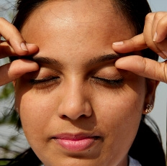
- Roll your eyes 5-6 times clockwise and then anticlockwise.
- Pull your ears for 10-15 seconds. Scientists say that all the nerves that increase awareness are located in the lower part of the ear.
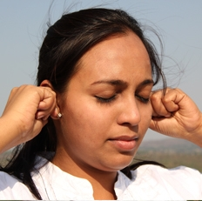
- Hold your ears and move them clockwise and anti-clockwise (as if riding a cycle) till your ears become hot.
- Move three fingers (first, middle, and ring finger) from the jaw line to chin and massage your cheeks. You could keep your mouth open as you do this. Did you find knots in the space between your jaws? This is a place where stress hides. See how 'knotty' you have been and iron out all the knots.
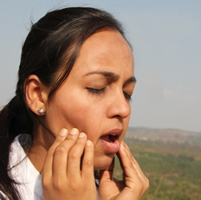
- Open and close your jaw 8-10 times.

To end …

Close your eyes, place one hand on chest and one on abdomen, breathe in and out of abdomen 5 times.
Keeping eyes closed, think of 3 things you are grateful for and smile …

References
Adapted from http://www.artofliving.org/yoga/off-yoga-mat/sukshma-yoga-relaxation accessed 26/7/16

Alison Leach
BA (Hons), BWYQ Dip
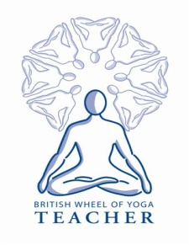 alisonleach@talktalk.net (Mob: 07715 174734)

